# **Home page of vx-mart**

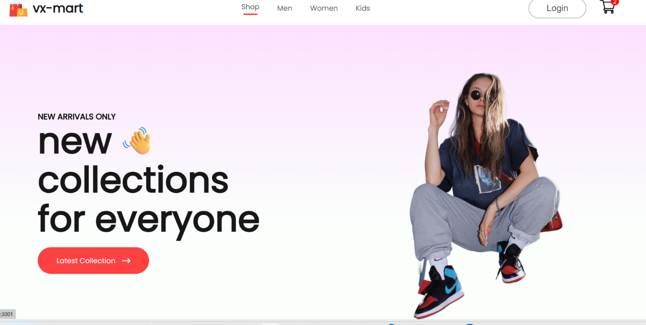

# **Women dress categories**

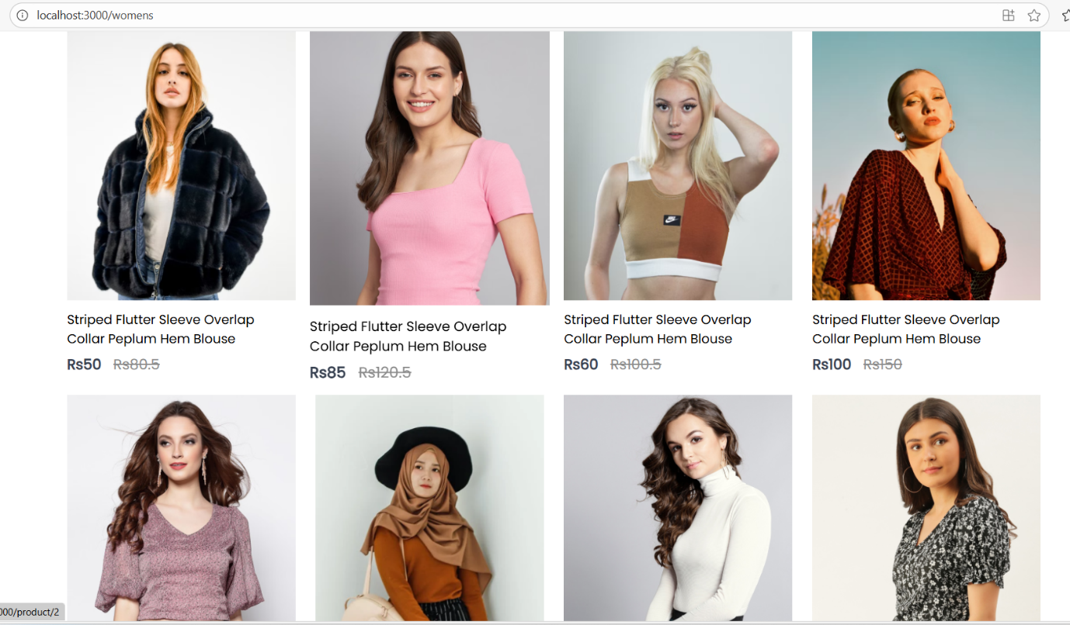

# **Mens categories**

# **Cart page**



# **Cart addinf show page**



**The cart trolly show when we click the add to cart its add the product showing in numbers**

# **Login page**

# **Cheak out page**

